Ideation Phase
Empathize & Discover

Date | 18 February 2026
Team ID | LTVIP2026TMIDS79720
Project Name | Advancing Nutrition Science through Geminiai
Maximum Marks | 4 Marks

Empathy Map Canvas:
An empathy map is a simple, easy-to-digest visual that captures knowledge about a user’s behaviours and attitudes.

It is a useful tool to helps teams better understand their users.
Creating an effective solution requires understanding the true problem and the person who is experiencing it. The exercise of creating the map helps participants consider things from the user’s perspective along with his or her goals and challenges.

Example: Advancing Nutrition Science through Geminiai
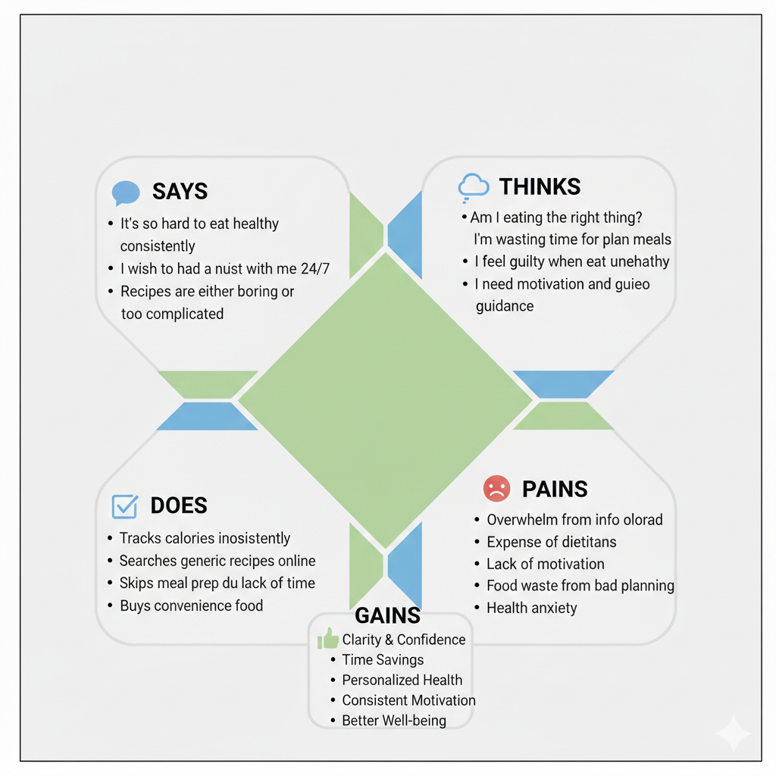
This empathy map captures the lived experiences, motivations, frustrations, and aspirations of food bloggers and home cooks who regularly create, share, and search for recipes online. It is designed to inform the development of RecipeMaster, an AI-powered smart recipe blogging and food assistance system.

- SAYS (Outer Communication)
This section captures what the user expresses out loud.
The Struggle: It’s so hard to eat healthy consistently. This shows the user wants to be healthy but lacks a sustainable system.
The Need for Guidance: I wish I had a nutritionist with me 24/7. This justifies why you built the Virtual Coaching feature.
Content Fatigue: Recipes are either boring or too complicated. This highlights the need for your Tailored Meal Planning to provide variety without being overwhelming.
- THINKS (Internal Monologue)
This represents the user’s private thoughts and anxieties.
Doubt: Am I eating the right thing? Even when they try, they lack confidence in their choices.
Time Anxiety: I'm wasting time planning meals. They view health management as a chore rather than a lifestyle.
Guilt: I feel guilty when I eat unhealthy. This points to the psychological pressure your Health Verdict feature helps alleviate by providing facts instead of judgment.
- DOES (Observed Behaviors)
This section outlines the actions the user currently takes often unsuccessfully.
Inconsistency: They track calories sporadically because manual apps are too slow.
Search Fatigue: They look for generic recipes online that don’t fit their specific allergies or goals.
- PAINS (The Challenges)
These are the obstacles and negative emotions the user faces.
Information Overload: Too much conflicting advice online.
High Costs: Professional dietitians are too expensive for the average person.
Health Anxiety: Constant worry about long term wellness and lack of motivation.
- GAINS (The Desired Outcomes)
This is what your NutriGen project provides to the user.
Clarity and Confidence: No more guessing. The AI gives a clear Health Verdict.
Time Savings: Automated 7 day plans and grocery lists save hours of planning.
Personalized Health: A system that actually knows their allergies and fitness goals.
.

